**Assignment 1**

Write code that performs the following functions or that answers the question. Feel free to do this in R, then copy + paste your code into the assignment turn in space.

1. **ChickWeight** is an R built-in dataset (similar to sleep that we talked about in class). Weight is currently in grams. Convert to kilograms (1g * .001 = 1kg) and store in variable **q1.**

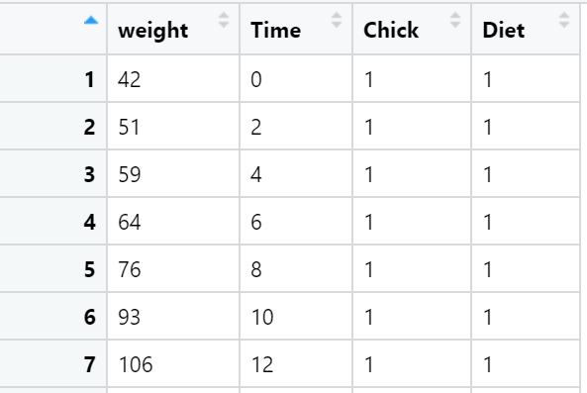

|  |  |  |
| --- | --- | --- |
| **Column name** | **Description** | **Possible values** |
| weight | Body weight of the chick (gm) | Numeric values |
| Time | Number of days since birth when the measurement was made | Numeric values |
| Chick | Chick ID | 1, 2, … 49, 50 |
| Diet | Diet ID | 1, 2, 3, 4 |

1. Determine the minimum, maximum, mean, and median of all the collected chick weights in kilograms. Store in variables **q2a, q2b, q2c**, **q2d** respectively.
2. How many weight measurements were collected? Hint: this is equal to the number of rows in the dataset. Store in **q3**.